How do Base and Coserv interact?
- There is not a fixed monthly MWh that Coserve gets
  - Coserv can get up to 100 MW from Base (upper limit on energy available in optimization problem)
  - Coserv has the right to call upon that power output as needed
    - What prevents Coserv from requesting more power than they actually need?
- Contractual call caps: contract specifies maximum number of ‘call’ events per year. Coserv cannot just call an event every day just to lower regular wholesale purchases. How many events are allowed? (Num events / yrs < 125)
- Each call is typically capped at a discrete window / time duration. What is the time duration? (Event duration < 2 hours)
- Coserv can call events any time of year, HOWEVER it is in their best interest to call them during summer 4CP and winter freezes (because this is when grid has least reliability and power prices are highest).
- Our optimization equation was going to be maximizing base power revenue. Perhaps additional optimizations:
  - Maximize Base and minimize Coserv power expenses: If we just maximize base revenue, that would put Coserv dispatching during sub-optimal times for them. When in reality Coserv is also trying to ensure reliability and save on power costs
  - Maximize grid reliability
- Base software validates Coserv’s requested energy usage against contractual limit.
- There is 20% homeowner reserve floor (Coserv cannot have this energy)
- Discharging is constrained by inverter ratings and thermal boundaries. Industry standard of these?
- Software controls how much power battery is allowed to dispatch
- Coserv pays baseline capacity fee. What is this penalty amount? Occurs when?
- Coserv capacity fee: monthly fee $6-12 per kW month of committed capacity
- Base failure to deliver: If Base fails to deliver > 90% of Coserv’s requested capacity, Base forfeits portion of capacity payment and faces availability penalty (1.25x-1.5x hourly capacity value)
  - failure penalty = ??
- If Coserv calls for power during an ERCOT market spike without actually desperately needing it, they may be liable for Base’s lost revenue
- Discharging too much power during mild load periods can cause power to flow backwards → grid instability

Factors that Determine the Amount of Energy Coserv Requires
General Notes
- Coserv purchases power from the wholesale mkt
  - When ERCOT real time prices surge → Coserv uses Base’s power
    - A major driver of Coserv’s transmission costs occurs during ERCOT’s 4 main 15 minute grid-wide peaks in June/July/Aug/Sept. Coserv uses Base’s pwr during these peaks
  - During extreme heat + cold, Coserv uses Base’s battery power to reduce transmission congestion

Constraint Equation Formulation
Time Intervals on basis of: 15 minutes
Number of Events / Year < 125
Event duration < 2 hours ←→ Event duration < 8 time intervals
Max power available: Reserve in homes + dispatch to utility + Base’s power = 100 kW
Reserve in homes: Each battery needs to maintain (0.2)(11) = 2.2 kW
- Base Power deploys home units—such as the 39.2 kWh Base Core featured in their CoServ PeakTime Perks program—equipped with an inverter rated between 11 kW and 11.4 kW continuous output (Implies they need ~ 9091 batteries if rated 11 kW)
Piecewise function to factor in altered inverter max power based on weather:
- 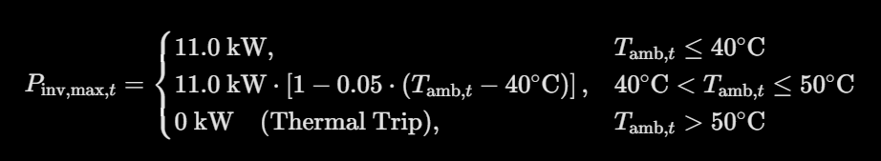
CoServ baseline capacity fee: Capacity Fee = Capacity monthly fee / kW month * committed power (kW)

Base failure to deliver penalty: If kW delivered < 0.9 * kW requested
- shortfall = (0.9 * amt requested) - amount delivered (kW)
- penalty:
  - hourly rate = capacity monthly fee rate / 720 (where 720 = # hrs in month)
  - penalty = (1.25)(hourly rate)(shortfall)(hours)
    - instead of doing it on hourly basis, may want to do it on 15 min interval timing, so 1 hour is 4 15 min intervals)

Battery charge limitations for each battery:
- Total capacity for a Base battery: 39.2 kWh
- Safety floor: 20% * 39.2 kWh = 7.84 kWh
- Max continuous power output possible: 11 kW (inverter rating for each battery)
- Temperature power output derating:
  - See screenshot above of piecewise function for altered inverter power
- Depletion equation: Energy remaining (t+1, kWh) = Energy at time t - (Discharge rate, kWh)(0.25)
- 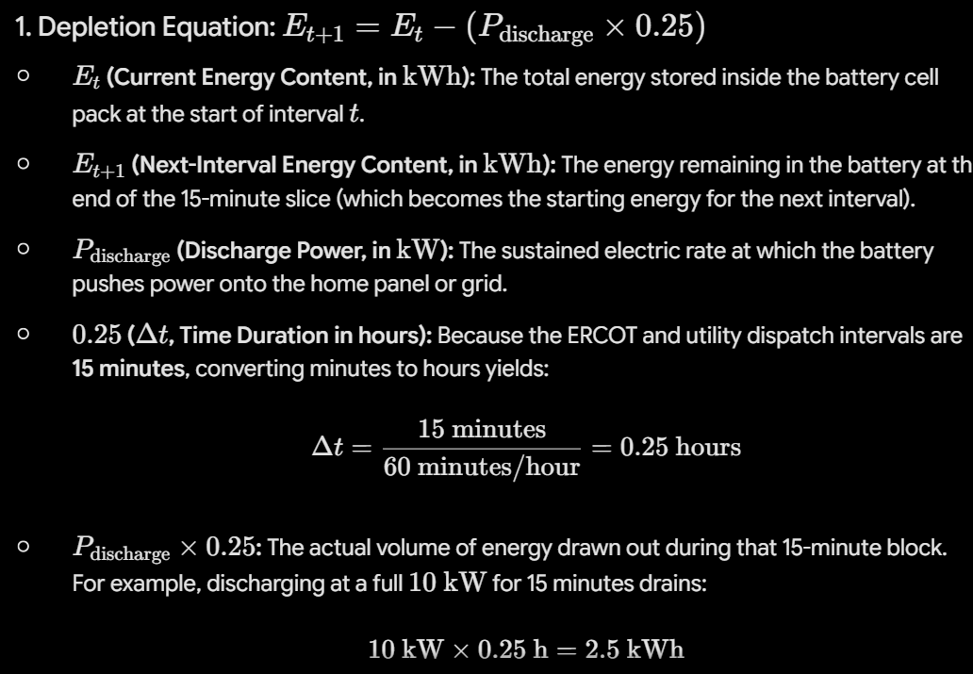
- Recharging equation: Energy at t+1 = min(Total energy at t, Energy at t + (Rate at which battery takes power from solar or grid in kW * 0.25 * efficiency η )
  - use efficiency η = 0.92
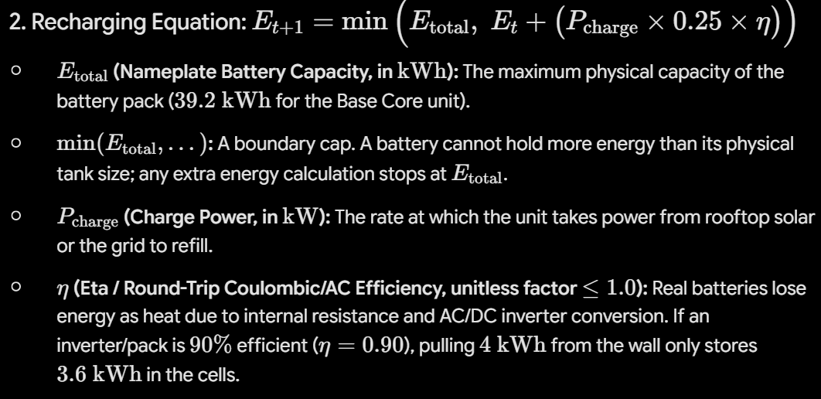
- Available Power Constraint: Power available = min(Interter limit, (Energy at t - Safety floor reserve)/0.25), we divide usable energy by 0.25 to get the exact continuous power level that would drain the battery right to the floor in 15 mins
  - make assumption batteries charging from the grid
  - battery charging from grid acts like electric appliance. on standard residential 200A split phase service panel (240V), an 11 kW continuous draw demands I = 11,000W / 240V = 45.8A. Under national electrical code, this requires 60A dedicated breaker. If a home panel only has headroom for a 30A or 40A breaker, charging power is throttled to 5.7-7.6kW. What percent of homes have 200A (240V) service panel, vs other lower rated?
  - 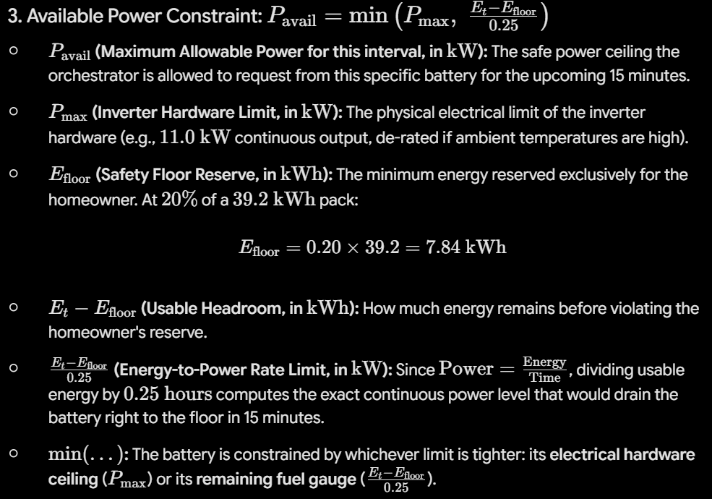

How can we specify that Coserv is only allowed to make a call during certain periods of time?
- Can we include a computation that captures the ‘benefit’ to Coserv for making a call during a particular time? The benefit will factor in the time (so need to define a dict / some other data structure with time intervals and a reflection of the power demand in that time interval). And set constraint that Coserv’s benefit of making a call during time t must be at least X for them to make a call during that time / under those market conditions? And this means if benefit is not significant enough, then ‘call’ not made → power only goes to Base + home owner
  - ALSO! Under this framework, just because Coserv can theoretically make a call, they aren’t going to make a call at every moment that they are allowed to do so (only allowed to make a call a fraction of the time (due to limited number of calls + call time duration). Not sure if we want to implement a condition that says ‘If condition adequate to make a call, randomly generate whether a call occurs based on this probability, where is the probability is the ratio of time available to have a call active / amount of time interval we define when a call would be valid (based on condition of Coserv getting enough benefit from the call). If we are making our simulation do what is most realistic, that is likely best approach, but that is not practical for demo because ideally when we modify our settings to be conditions such that a call could be made (Coserv may potentially want to draw power due to high power prices), we will probably want to show our simulation doing that, not have the program randomly decide based on probability (call frequency limits) whether a call is actually made and whether Coserv actually gets power. Because then a large proportion of the time when we run simulation under conditions where call ~could~ be made it may still result in Base + homeowner getting all power
- Thus, proposal: define a data structure that includes the time and the ‘benefit’ of Coserv (based on understanding of how much energy demand there is during that time of day & year). Our simulation will also accept a time value. If the input time value corresponds to a time of sufficient benefit for Coserv to make a call → call is initiated and power gets split between Base and Coserv. Then, if we have this limitation in place, we can maybe just maximize Base revenue. .?

Constructing Time Intervals for Valid Calls
- Create data structure that stores when CoServ is allowed to call
- Define this based on what ERCOT’s real time dataset variables look like
- We will use this data structure to validate if a time call is valid. If it is, we will lookup system load peak and compare current load data (from ERCOT real time load) to determine benefit metric
- Steps for examining validity of call:

1. Is interval t within valid time interval?
├── NO ──> 4CP Term = 0 (CoServ call blocked unless feeder emergency)
│
└── YES ──> Pull live SystemLoad(t) from ERCOT Load Dataset
│
▼
Compute Stress Ratio:
LoadRatio = SystemLoad(t) / HistoricalPeak
│
▼
Evaluate Benefit Metric B_t:
B_t = w_4CP * LoadRatio + w_temp * ΔT + w_price * λ_t
│
▼
Does B_t exceed Threshold?
├── YES ──> CoServ triggers call
└── NO ──> No call; Base sells to wholesale market

Determining Calibration Weights (Benefit Metric)
Ground weights in dollar value per kW shaved:
- Benefit = (Transmission avoidance weight)(Valid call time indicator)(Load/Peak) +
(Temperature weight) * Max(0, Temp t - Temp threshold) +
(Price weight)(Power price)
- Transmission avoidance weight: $15
- Price weight: (power price $/MWh) / 1000 kW/MW * (0.25)
- Temp weight: 0.02
- The benefit metric should not only inform whether a call event is valid, but also the proportion of the 100 kW that Coserv requests.

Optimization Formulation
Maximize Base revenue
At each 15 min interval, the orchestrator solves an optimization program to maximize Base Power's net margin while prioritizing CoServ's call to avoid failure-to-deliver penalties.

MAX (Wholesale arbitrage revenue of Base) -
(Fleet recharging costs) +
(Fixed Coserv capacity fee) -
(Base’s Shortfall penalty pmt to Coserv)

MAX (Real time wholesale price [$/kWh] * Power sold to ERCOT [t, kW] * 0.25]) -
(Off peak power cost to charge [$/kWh] * Σ (Power drawn from grid to charge [kw]) * 0.25) +
(Coserv monthly capacity rate [$/kWh] * Committed fleet capacity (100kW) * 0.25/720) -
Penalty [t]

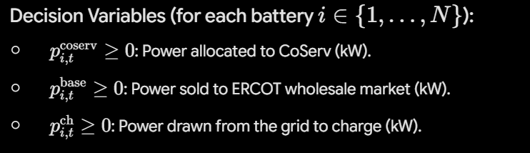
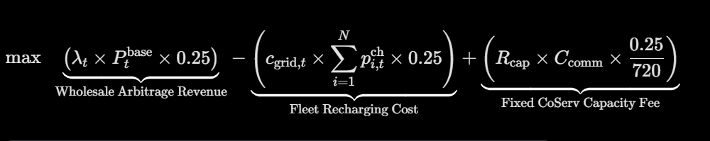
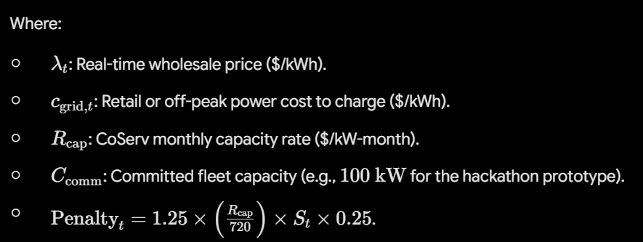

Prompt for Writing Dispatch Function
i want to write the code for the dispatch function. the function should output the percent power that will go to base power and the percent power that will go to coserv. our optimization function intends to maximize base's revenue. more details about the optimization function and constraint functions are listed on the dispatch formulation doc. the data that will be input into the model and the connection points for the api are listed in the base data sources doc. i want our optimization algorithm TO TELL ME the amt of energy that coserv should request, subject to those constraints i listed and optimizing for base revenue. the algorithm is solving for the amount of power that should go to base vs to coserv. construct the function for dispatch. let me know if you have further questions.

After getting AI Output, evaluate. **AI Ignore this**

